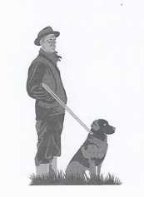
Participant Entry Form
Working Gundog Certificate

Venue/Date Participation Fee : £

PLEASE COMPLETE CLEARLY IN INK AND BLOCK CAPITALS.

ENTRIES FOR THIS CERTIFICATE WILL ONLY BE ACCEPTED FOR KC REGISTERED DOGS.
Registered name of dog: …………………………………………………………………………..
KC Registration number/Stud Book number: …………………………………………………
Breed: ……………………………………………………………………………………………………..
Sex: …………………………………………………………………………………………………………
Name of handler: ……………………………………………………………………………………….
Address: …………………………………………………………………………………………………..
Email: ………………………………………………………… Tel: ……………………………………..
Name of Registered owner(s) if different from above: …………………………………………
Address of owner: ……………………………………………………………………………………….
DECLARATION: (TO BE COMPLETED BY THE HANDLER). I agree to be bound by the Kennel Club Limited Rules and Regulations in their present form or as they may be amended from time to time in relation to all canine matters with which the KC is concerned. I also undertake to abide by the guidelines of the WGC in their current form contained within the WGC Handbook. I will not bring to any assessment: (a) a dog which has contracted, or knowingly been exposed to, any infectious disease during the 21 days prior to the assessment day or which is suffering from a visible condition which is affecting its health or welfare, or (b) a bitch in season.
Signed (Handler)……………………………………………………………… Date………………………….

